2026 SPRING SOCCER



9-10 Girls & Boys

BPAR SOCCER RULES & COMMITMENT GUIDELINES
- The BPAR Spring Soccer season runs from April to May. It is imperative that coaches, players and parents commit to their scheduled games.

- A player or team may participate in other leagues or tournaments but not interfere with BPAR games. Missing BPAR games for outside events may result in forfeits or removal from the program.

- Only registered players may participate. Players are only allowed to play for the one BPAR team they were officially assigned to at the start of the season. Fill-in players, including those from other teams or age groups, are not permitted. Any violation of this rule will result in an automatic forfeit.

- Coaches must attend the preseason meeting where additional rules and clarifications will be addressed.

- Coaches must check emails regularly for league updates, as it will be the main correspondence from BPAR.

- FIFA rules apply with local exceptions & points of emphasis. BPAR may adjust rules, as needed, to maintain league integrity. The rules listed below are NOT all inclusive.

GAME SCHEDULING
- If a division has an odd number of teams, teams may be required to play more than the standard seven (7) games. BPAR will strive to ensure that all teams have as equal a number of games as possible.
PLAYOFF DETERMINATION – TOP 4 TEAMS

Ties will be determined as follows:

1. Head-to-Head Record
- The team that won the match between the tied teams ranks higher.

2. Goal Differential
- (Goals scored - Goals conceded) over all games in the season.

3. Goals Scored
- The team with the most total goals scored ranks higher.

4. Fewest Goals Conceded
- The team that allowed the fewest goals during the season ranks higher.
5. Coin Toss

PLAYER AGE & ASSIGNMENT
- Playing Age is as of September 30th, 2025.

- Coaches may turn in a roster for requested players. Furthermore, players will be assigned to teams, first by the players’ residential zip code or school attended. Players may be assigned to teams not within their residential zip code or school attended to accommodate the league.

PLAYER SAFETY
- To protect the safety of all players in the program, any participant wearing a cast will prohibit them from participating in BPAR games or practices. Exceptions can be made with approval from the Youth Sports Supervisor and documented approval from a physician.

- Soft casts will be permitted if approved by officials.

- All types of jewelry or headbands (earrings, bracelets, necklaces, metal barrettes, hair beads, hair clasps etc.) or hats must be removed before the game.

- Adaptive or medical aids are approved on a case-by-case basis.
PROTESTS
There are no game protests in this league. All game official and/or BPAR staff decisions are final.

WEATHER
- Games will proceed in rain but will be canceled for lightning or any weather creating unsafe conditions.
- Weather-Interrupted Games: If a game is stopped due to severe weather after reaching halftime, it will be considered a complete game and will not be rescheduled. If the game is stopped before halftime, it will be rescheduled and resume from the point it was stopped, including half, possession, and score.
- BPAR officials will assess field conditions and may shorten periods, suspend, or cancel games if fields become unsafe due to heavy rain.
- Communication regarding cancellations or weather updates will be sent by email to head coaches and/or parents.
- In the case of multiple cancellations, the schedule may be adjusted (e.g., doubleheaders), but rescheduling is not guaranteed due to external factors.
- BPAR’s goal is to do our best to provide every team with the standard 7 games each season. However, we will not schedule beyond November 1st as stated in the registration, in order to respect all participants' time and previously planned commitments.
- If a rescheduled game cannot be made up by one or both teams involved, it will result in a forfeit and will not be rescheduled at a later date.

UNIFORM
- Each player must have on their BPAR issued jersey. Advertisements are not allowed. Individuals or teams are allowed to have players name on the back of the jersey.
- Age specific shin guards underneath their socks are required.
- Cleats are recommended but not required. Players may wear any color cleats, but they must be soccer-specific—NO football cleats (cleats with a front toe stud) or metal/steel cleats are allowed.
- Shorts: Any Color, No pockets, Entire team must be uniform Socks: Black, white, or team color
- Non-uniform/Under kit clothing is allowed but must match the uniform color or black.

SPORTSMANSHIP – Coaches, Players & Spectators
- Unsportsmanlike / Unbecoming Behavior
  - Unsportsmanlike behavior toward officials, coaches, players, teams, or spectators is strictly prohibited.
  - BPAR staff and officials have the authority to determine inappropriate conduct by coaches, players, teams or spectators including but not limited to intoxication, verbal abuse, taunting, profanity, or physical intimidation.
  - Offenders will be required to leave the event immediately and may face permanent bans from BPAR events.
- Game Safety & Enforcement
  - Officials may end a game if the atmosphere is unsafe or violates BPAR values.
  - Any conduct, which is deemed unsportsmanlike in the opinion of the referee, will result in a warning. Depending on the severity, the game may be stopped, and the player, coach, or spectator may be ejected from the game without a warning.
    - Ejected individuals must leave immediately.
    - The game will not continue until the ejected party has left the premises.
    - If they do not leave, the referee will forfeit the game immediately and award the win to the opposing team.
- Suspensions & Dismissals
  - If ejected, that individual would fall under suspension from BPAR and would not be allowed on any BPAR premises until reinstated by BPAR.
  - Ejected individuals may face suspensions ranging from one (1) game to the entire season.
  - If a 2nd ejection occurs, they will subject to dismissal from the BPAR league.
  - BPAR reserves the right to remove any coach, player, or spectator at any time for unsportsmanlike or unbecoming misconduct for a BPAR event.

See the Cautions section for more details on the handling of
yellow and red cards.

COACHES
- Must show respect toward spectators, opponents, referees and BPAR staff.
- A maximum of three (3) coaches are allowed on the sideline during the game.
- Coaches are NOT allowed on the field of play.
- Inform parents about the consequences of inappropriate behavior towards officials.
- Are responsible for cleaning up their bench area after the game.
- BPAR-Specific Rule: BPAR assigns officials; if BPAR officials are unavailable, coaches must referee the game. Games will stop 60 minutes after the scheduled start time to maintain scheduling.

SPECTATORS
- Must show respect toward other spectators, players, coaches, referees and BPAR staff.
- Must sit on the opposite side of the field from players and behind the outermost line.
- Are NOT allowed to sit or stand behind the soccer goals.
- Anyone using inappropriate language or yelling at anyone will be required to leave the field.

REFEREES
- The referee is the final authority on the field.
- Disrespectful words or behavior toward referees will not be tolerated.
- Games may be stopped, suspended, or terminated due to interference from coaches, players, or spectators.
- Referees can remove coaches, players, parents, or spectators if necessary to maintain control and a positive atmosphere.
- BPAR-Specific Rule: BPAR assigns officials; if BPAR officials are unavailable, coaches must referee the game. Games will stop 60 minutes after the scheduled start time to maintain scheduling.

9-10 Girls & Boys Basic Breakdown – 7 Game Season – No Playoffs
Age Division  (as of Sept. 2025) | # Players on Field  (Includes Goalie) | Goalie | Game Length*  (5 Min. Half-Time) | Offsides | Heading | Yellow/Red Cards | Ball Size | Goal Size | Field Size
9 - 10 yrs | 9 v 9 | Yes | 2 x 25 min halves | Yes | No | Yes | 4 | 6.5’H x 18’W | 50 yds x 80 yds

SOCCER RULES
NOT ALLOWED in 9-10’s
- Heading – Intentionally, hitting the ball with the forehead to control it. Will result in an indirect free kick.

- Slide Tackling – a defensive move, where a player slides on the ground to take the ball from an opposing player.

- Hand Ball – Will result in a free kick taken from the point of the foul.

- Offsides – when the offense is in the opponent's half of the field and closer to the goal than the ball and the second-to-last defender. Offsides WILL be ENFORCED.

- No Rough Play is allowed.

PLAYERS & GOALIE
- Games are played with 9 vs. 9 on the field.
- This division uses a goalkeeper, who must wear a different-colored jersey than their teammates.
  - BPAR provides a limited supply of pennies for goalkeepers on game days.
- Everyone must play and No player is allowed to play the entire game, except for the goal keeper.

PLAYER PRIVLEGES
All players may play the ball with their feet, head, knees, chest, body, or shoulders. Only the goalie may touch the ball with upper arms, forearms, or hands as long as they remain in the penalty area.

START OF PLAY/ KICK OFF
To start a game, a half and after a goal, the kick-off is performed at the mid-field line by one of the offensive players.
The ball will be considered in play when it has been kicked and is moving in any direction. The defensive team must line up ten (10) yards away from the ball (outside of the circle) and cannot touch the ball until it is in play. Both teams must be in their respective halves of the field at the kick-off. The player kicking off cannot touch the ball a second time until it has touched another player.
SUBSTITUTIONS
Substitutions are allowed during the following situations:
- Restarts of play, your own throw-in, your opponent’s throw-in, if they are also substituting
- Goal kicks or after a goal is scored
- If a player becomes ill or injured
- If a player receives a yellow card
  - They may be substituted, and the opposing team may match the sub
- If a player receives a red card
  - They must leave the field, and the opposing team may match the sub

Additional Guidelines:
  - Teams must request substitution permission from the referee
  - Substitutes should kneel at the midfield line before requesting to enter
  - No player may enter the field until the referee signals them on

RESTART
When a ball goes out of play, the game is restarted by one of the following:
- The ball crosses over the sidelines, a throw-in will be taken.
  - Throw-Ins: The ball must start behind the players head with 2 hands on the ball & 2 feet on the ground. The player must follow through after the throw.
  - If a foul throw-in occurs, it will result in a loss of possession.
- The ball crosses over the end line and was
  - Last touched by the attacking team, a goal kick is awarded.
  - Last touched by the defending team, a corner kick is awarded. Any offensive player may take the kick.

KICKS
All opposing players must be at least ten (10) yards from the ball on all free kicks, goal kicks, or corner kicks. Player kicking the ball is not allowed to touch the ball again until another player touches it.

SCORING
- A ball that is kicked between, but not over the goalposts at the opponent’s goal line, is considered a score equal to one (1) point. The ball must be completely over the entire goal line to be considered a goal. The ball does not have to touch the net to be considered a goal.
- Goals can be scored anywhere on the field. Goals may not be scored directly from a throw in.
- Scores will be recorded and published online.

FOULS, MISCONDUCT & PENALTIES
*DIRECT FREE KICKS
A direct free kick (or penalty if within the offending team’s penalty area) is awarded when a player commits any of the following with careless, reckless or excessive force:

- Kicks or attempts to kick an opponent
- Trips or attempts to trip an opponent
- Jumps at an opponent
- Charges an opponent
- Strikes or attempts to strike an opponent
- Pushes an opponent (shoulder to shoulder is legal if both players are challenging fairly)
- Tackles or challenges an opponent unlawfully
- Holds an opponent
- Spits at an opponent
- Handles the ball deliberately (excluding the goalkeeper within their own penalty area)
- Impedes an opponent using contact
- Throws an object at the ball, opponent, or match official – or makes contact with the ball using an object held in the hand.
- The referee will signal a direct free kick by pointing their arm horizontally in the direction of the attacking team’s play.
- Penalty Kick: If any of these offenses occur inside the offenders’ penalty area, a penalty kick is awarded instead of a free kick.

*INDIRECT FREE KICKS
An indirect free kick is awarded for the following non-penal offences:
- Playing in a dangerous manner (e.g., high foot into an opponent)
- Impeding the progress of an opponent without contact
- Dissent (verbal or gesture)
- Preventing the goal keeper from releasing the ball
- Kicking or attempting to kick the ball while the goalkeeper is releasing it
- Deliberate trick to circumvent the back-pass rule (e.g., flicking to the goalkeeper)
- Technical goalkeeper handling offenses (holding the ball too long, handling after back-pass or throw-in)
- Offsides penalty (9-10s, 11-13s)
- Any other non-contact offense that stops play and warrants caution or send -off
- Illegal intentional play of the ball with the head
- The referee will signal an indirect kick by raising one arm straight above their head, the arm remains up until the ball is touched by another player or goes out of play.

PENALTY KICKS
- A penalty kick is awarded as punishment for any infringement of the rules which ordinarily requires the awarding of a direct free kick if the foul is committed by a defending player within the penalty area.

- The foul must be deliberate. A defensive player should never make a penalty kick. When awarded, the penalty kick will be made from the penalty spot.

- All players, except for the players taking the kick and defending the goalkeeper, must be outside of the penalty area. The ball must be kicked forward. If a foul is committed by the attacking team inside the opposing team’s penalty area, the defending team will be awarded a direct free-kick from the point of the foul.

*OFFSIDES RULE
A player is in any offsides position if, at the moment the ball I splayed or touched by a teammate:
They are closer to the opponent’s goal line than both the ball and the second-last defender (usually the last defender + goal keeper). Simply being in an offside position is not penalized. Additionally, a player is NOT in an offside position if they receive the ball:
- Directly form a goal kick, throw-in, or corner kick
- While in their own half of the field at the moment the ball is played
- When level with the second-last opponent or the ball
The penalty occurs when:
- Interfering with play – touch or playing the ball
- Interfering with an opponent – block vision, challenging for the ball, or affecting the opponent’s ability to play it.
- Gaining an Advantage – playing a ball that rebounds or deflects to them off the goalpost, crossbar, or an opponent.

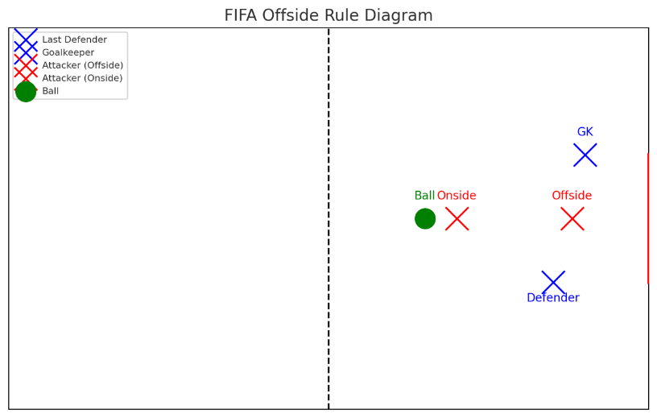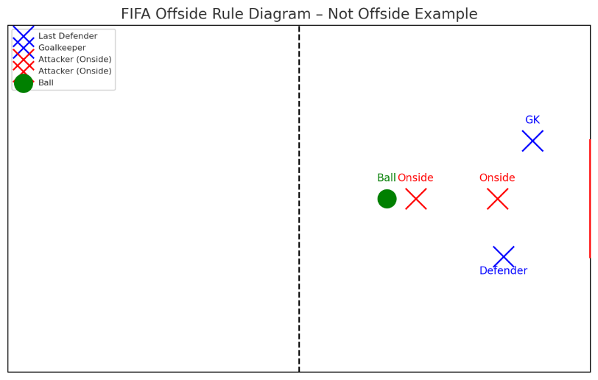

CAUTIONS

🟨 YELLOW CARD (CAUTION)
Player Cautions:
- A player may be cautioned (shown a yellow card) for reasons including, but not limited to: persistent fouling, dissent (arguing with the referee), delaying the restart of play (time-wasting), unsporting behavior, failing to respect the required distance during restarts (free kicks or throw-ins), or entering/leaving the field without the referee’s permission.
- Not all fouls warrant a yellow card. A player may be shown a caution if, in the opinion of the referee, the player has acted unsportsmanlike (as defined by BPAR), carelessly, recklessly, with excessive force, or dangerously.
Player In-Game Consequences:
- Player is warned and may stay in the game (coach may sub for a “cool down”).
- Referees will briefly explain the reason for the caution if needed.
- Two yellow cards = red card (ejection).
Coach Cautions:
- A coach may be cautioned (shown a yellow card) for reasons including, but not limited to, dissent, unsporting behavior, or failure to control sideline conduct.

🟥 RED CARD (EJECTION)
Player Ejections:
- A player may be sent off (shown a red card) for reasons including, but not limited to: violent conduct or serious foul play, using offensive, insulting, or abusive language or gestures, spitting, or denying an obvious goal-scoring opportunity by handball or foul. A second yellow card in the same match will also result in a red card and ejection.
- A player may be shown a red card and sent off, in the opinion of the referee, for slide tackling, causing bodily harm, continued violations, inappropriate behavior, unsportsmanlike conduct (as defined by BPAR), or any other form of dangerous play.

Player In-Game Consequences:
- Player is ejected and cannot be replaced. Team plays down one player.
- The player must leave the field and may remain on the bench, unless the referee directs them to leave the complex.
- Referee files a game report describing the incident.

Coach Ejections:
- If a coach is shown a red card, they must leave the complex immediately.
- The game will not continue until the ejected party has left the premises.
- If they do not leave, the referee will forfeit the game immediately and award the win to the opposing team.
- Coaches may not communicate with the team or referee once ejected.
Post-Game Consequences:
Player:
- 1 Red Card or 2nd Yellow Card in Same Game = Ejection
- Red Card = Automatic 1 game suspension
- Multiple yellow cards over multiple games (typically 3) may result in a 1-game suspension.
- Serious misconduct (ex. Fighting, referee abuse) may result in multiple-game suspensions or possible removal from the league, pending BPAR review.
- Ejected individuals may face suspensions ranging from one (1) game to the entire season.
- BPAR has the right to review any and all actions as it pertains to BPAR events and the persons involved.
Coach:
- The ejected coach would fall under BPAR suspension and would not be allowed on any BPAR premises until reinstated by BPAR.
- Ejected individuals may face suspensions ranging from one (1) game to the entire season.

